Galaxy of universe?

To describe space you need to use the just right word.

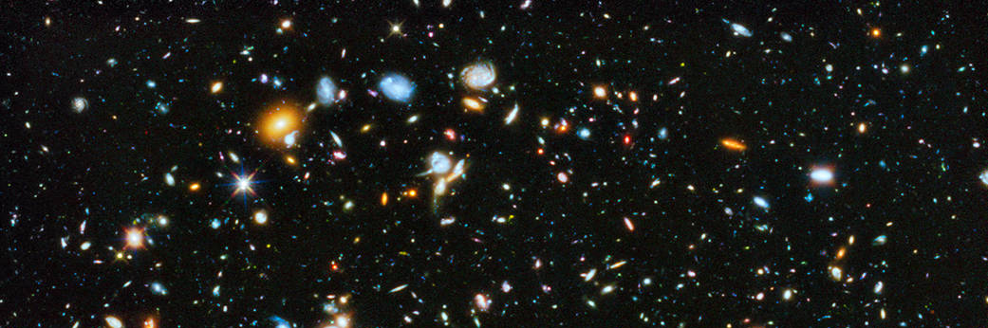

To do
Fill in the gaps to describe space.
You should only use the words galaxy and universe.

Space – a really, really big place
The whole of space and everything in it is called the _____________.
In the _____________ stars bunch together in huge groups. Each group of stars is called a _____________.
There are billions of stars in one _____________.
We live in a _____________ called the Milky Way. The Milky Way is just one _____________ out of many billion in the _____________.

Physics > Big idea PES: Earth in space> Topic PES1: Solar System and beyond > Key concept PES1.3: Night sky, stars and galaxies
Diagnostic question
Galaxy of universe?

Overview
Learning focus: | The Sun is one of billions of stars in our galaxy and our galaxy is one of many billions of galaxies in the universe.
Observable learning outcome: | - Describe how stars group together, billions at a time, to form galaxies and how there are billions of galaxies in the Universe
Question type: | Diagnostic, focused cloze
Key words: | Galaxy, universe

What does the research say?
A study found that US college students (aged 17-19, n=199) commonly provide incomplete definitions of common objects: Solar System, galaxy and the Universe itself, often conflating the terms (Bailey et al., 2012).
This question can identify how students are using key terms, and provides information about their understanding of the large scale structure of space.
Ways to use this question
Students should complete the activity individually as a pencil and paper exercise. The text on the worksheet is larger than standard so that the sheet can be copied at A5-size.
How students fill in the gaps will show you whether they understood the concept sufficiently well to apply it correctly.
If there is a range of answers, you may choose to respond through structured class discussion. Ask one student to explain why they gave the answer they did; ask another student to explain why they agree with them; ask another to explain why they disagree, and so on. This sort of discussion gives students the opportunity to explore their thinking and for you to really understand their learning needs.
Differentiation
You may choose to read the sentences to the class, so that everyone can focus on the science. In some situations it may be more appropriate for a teaching assistant to read for one or two students.

Expected answers
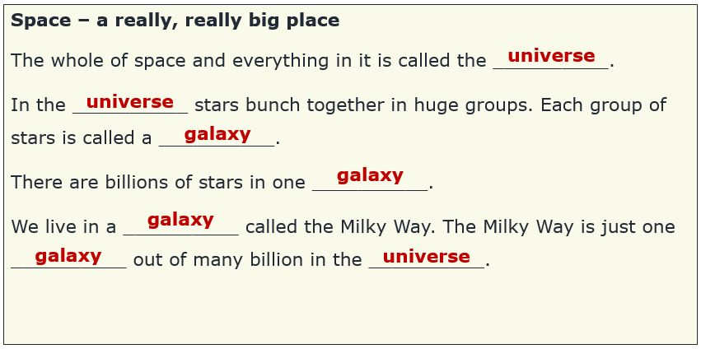
How to respond - what next?
Before Hubble found evidence that other galaxies existed in 1929, the stars in our galaxy were thought to make up the whole of the observable universe. We now know that the universe contains many billions of galaxies on an unimaginably large scale. It can help students to understand this structure more clearly using animations from the internet:
Powers of 10™ (1977) is a classic animation by Eames. The first six minutes take the viewer from a picnic in Chicago to deep space and back.
Scale of the universe 2 is a more modern version by Cary and Michael Huang. This can be found both as a video and as an interactive activity online.
Giving the students an activity in which they can practise using these ideas can help to consolidate their understanding. This could be drawing a cartoon or writing a story about a journey through deep space. This response often works best when it involves paired or small group discussions, which encourage social construction of new ideas through dialogue.
Relatively little research has been completed on students’ understanding of distances in space and the research that has been done indicates that this is one of the weakest areas of knowledge in astronomy for 11-16-year-olds (Lelliott and Rollnick, 2009). For some students this might be an appropriate time to introduce the concept of the light year as a measure of distance – the distance light travels in one year (Light can travel from London to Edinburgh and back about 280 times in one second, which is 7½ times around the Earth).
Acknowledgments
Developed by Peter Fairhurst (UYSEG)
Images: NASA/ESA

References
Bailey, J., et al. (2012). A multi-Institutional Investigation of Students' Preinstructional Ideas About Cosmology. Astronomy Education Review, 11 (1).
Lelliott, A. and Rollnick, M. (2009). Big Ideas: A review of astronomy education research 1974-2008. International Journal of Science Education, 32:13, 1771-1799.

